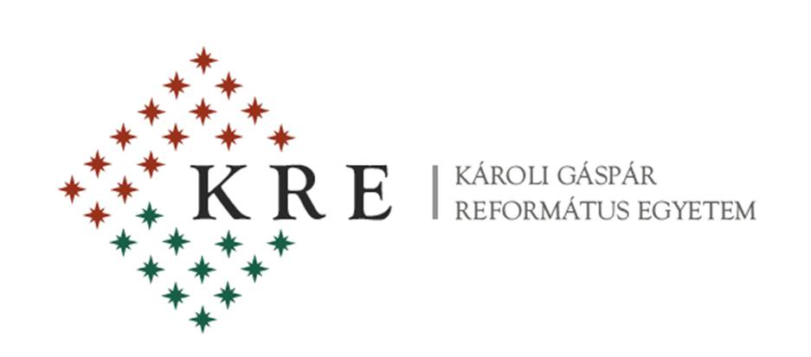

The Department of English Language and Literature &
The Department of Modern Languages
of Partium Christian University, Oradea (Romania)

in cooperation with

Károli Gáspár University of the Reformed Church, Budapest (Hungary)

are pleased to announce the 4th

ELLE

INTERNATIONAL CONFERENCE
on
English Language & Literatures in English
to be held on
12-13 September 2014
in Oradea, Partium Christian University

The conference committee welcomes original contributions on such topics as follows:

- American Literature
- British Literature
- Canadian Studies
- Central Europe and the English-Speaking World
- Cultural Studies
- ESP
- Ethnic Studies
- Gender Studies
- Intermediality
- Language Studies
- Literary Theory and Criticism
- Literatures in the English Language
- Multilingualism and Multiculturalism
- Philosophy
- Postcolonial Studies
- Religious Studies
- Translation Studies

Deadline for Submission of Proposals: 1 st June 2014

Those who wish to present a paper are kindly asked to fill in the registration form below and send it to galllaura@ymail.com

REGISTRATION FORM
First name:
Surname:
Affiliation:
Title of paper:
Abstract (100-150 words):
Key-words (4 or 5):
Minibio/CV (5 or 6 lines)

Conference fee:
Participants from Romania: 200 RON
Participants from abroad: 50 EURO

The fee will be paid upon arrival. The fee covers participation costs, coffee breaks, cocktail on the 12th (Friday), lunch and closing dinner on the 13th (Saturday), conference program. A selection of conference papers will be published in print.

Accommodation:

PC University Hostel: 10 EUR/night, in double or triple-bedded rooms; shared bathroom.
Atrium Hotel [www.hotelatrium.ro] – a ten-minute walk from the railway station.
Ramada Hotel [www.ramada.com/hotels/romania/oradea] – a ten-minute walk from Partium University.
Nevis Hotel [http://www.hotelnevis.ro/]

Conference Venue: The conference will take place in the university main building (36 Primăriei Street).

Oradea can be reached:

by train – from Bucharest (via Cluj-Napoca); from Timișoara (via Arad); from Budapest (Hungary).
by plane – from Bucharest; from abroad, we recommend landing in either Budapest or Debrecen (60 km.s from Oradea) or Cluj-Napoca (160 km.s from Oradea) and taking a train from there.

Getting to the university:

Take a cab from across the railway station. We recommend the HELLO, FULGER, CITY or START companies. If you feel like walking, follow the tram line past the CRIȘUL hypermarket on your right, make a right, and cross the bridge. From the City Hall turn right and in about five minutes you will reach the university main building on your right.

There is no tram or bus from the Oradea airport but cabs are available at all times.

We look forward to meeting you in Oradea in September 2014.

The Conference Organising Committee

